Handout and Rubric
***Signature Assignment/Individual Assignment 3:
Operations Management Plan
MGTU 315
Length: Paper: 8 to 10 page paper that follows all APA standards
Visual Display of Supply Chain for the chosen company (usually on one full page as an addendum to this assignment – it does not count in the page count)
Due: Week 8 by Sunday Midnight PST
Value: 260 Points Possible
Post: Week 8 Assignments

Review all of the comments from your instructor on Assignment 2 which was the outline for this assignment. Incorporate all of your instructor’s ideas and suggestions into the outline before beginning this assignment. The company that you wrote the outline on for Assignment 2 is to be the same company under review for this assignment.
Remember this assignment is for you to demonstrate that you have learned and can apply all that you have learned in this entire class; using the text, all course materials and participating in discussion threads. It is appropriate for you to cite the text book several times in this final assignment, along with citations from research from other business sources.
You are to build an Operations/Supply Chain Management Plan for the company you used in Assignment 2. The company was an actual business either a product or a service with sales between $500,000 to and $10 million. The purpose of the Signature Assignment is to have students show the entire supply chain (in graphics as well as an 8 - 10-page paper) of how materials are sourced, developed, built, packaged, stored, packaged, transported and stored and to develop the customer experience feedback loop. You are to include sustainability issues as well as cost of goods sold (COGS). This paper is not just to report on an existing company (although you must do that). Additionally you are to identify a problem that this company is experiencing or an opportunity that the company might consider. This problem or opportunity may be included in a Recommendations section for this paper, but the recommendations section of the paper is not to be more than one page of the eight to ten pages of the paper).
Part of this assignment will be a visual display of the supply chain for your chosen organization. See the PowerPoint in Week 8 documents for lots of options for what a supply chain can look like. You are not to choose one of the visual displays on the PowerPoint, but to research and analyze your chosen company and build a supply chain (based upon your research) of what the company you have chosen supply chain looks like. The visual display should in some ways connect with the eight to ten page paper and you may refer to the visual display in the paper.
Processes to follow for writing. Be sure to follow all APA guidelines and review sample APA paper and other writing helps found in Course Information, under “Writing Helps.” You are to follow all APA guidelines, use Times New Roman 12 font. Use APA headings as below:
You will have at least two level 2 headings under each level 1 heading and at least one of the level 2 headings will have a citation. The level 1 headings include at a minimum: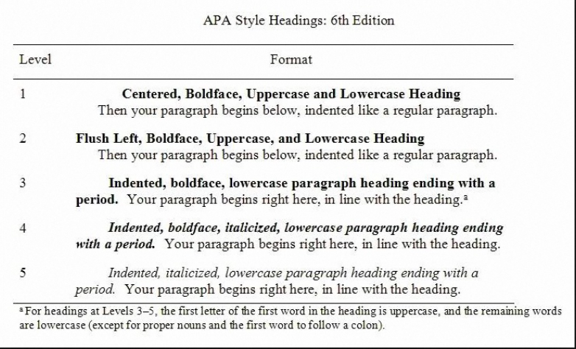
Introduction
Management Plan for XXX Company (includes, company website, industry information, purpose of the management plan, problem or opportunity to be explored, key descriptions of the product or service under review, etc.) This paper will have a minimum of fourteen level 1 headings (which are highlighted above in the graph)
Demographic of customer (use gov. data) https://www.usa.gov/statistics
Design of the Supply Chain (design for quality, delivery speed, deliverability reliability, or low cost and why which one of these four desirability’s will take precedence over the others based upon mission and vision and industry standards)
Material Resource Planning (MRP) (with a list of key suppliers with their websites, etc. connect plan to company mission and vision (cite).
Supplier Relationship Management Plan, (key terms and conditions)
Production (how much, where, when, who, how produced)
Packaging (what, how much, why, how this meets with the customer need)
Transportation (how, cost, why, does it meet customer expectations)
Cost of Goods Sold
CRM (Customer Relationship Management Plan)
Sustainability and CSR Plan (customer experience feedback loop)
Cost of Goods Sold
Recommendation
Conclusion
References
This paper is to be your best work in your business degree so far. You have an opportunity to create work that you could share with your current employer (to show how much you are learning) or to prospective employers (as you look for better jobs).
 | EXEMPLARY 260 | PROFICIENT 200 | DEVELOPING 140 | EMERGING 100
Content Accuracy | 52  The content of the Final Individual Assignment is thoughtful and accurate. A good blending of course material and personal experience. There are no factual errors. Applies terminology and concepts appropriately. Creates a clear communication plan for the operations turnaround. Connects to each of the Course Learning Outcomes, | 40  Most of the content of the Final Individual Assignment is accurate but there is one piece of information that seems confusing. Applies most terminology and concepts appropriately. Creates a somewhat clear communication plan for the operations turnaround. Somewhat connects to the Course Learning Outcomes. | 28  The content of the Final Individual Assignment is generally accurate, but one piece of information is clearly inaccurate. Applies some terminology and concepts appropriately. Plan for communicating the operations turnaround is somewhat unclear. Does not show a clear connection to each of the Course Learning Outcomes, | 20  The content is confusing or contains more than one factual error. Does not apply Operations terminology and concepts appropriately. The communication plan for the operations turnaround is unclear. Fails to connect with a majority of the Course Learning Outcomes.
Writing and Organization | 52  Writing is logical and organized. Sentences are well-phrased and varied in length and structure. Word choice is consistently precise and accurate. The writing is free of errors in grammar, spelling and writing mechanics. The report is the specified length of the assignment. 100% APA is accurate for citations, headings and reference page. | 40  Writing is generally logical and organized. Sentences are well-phrased and varied in length and structure. Word choice is generally precise and mostly accurate. There are occasional errors in grammar, spelling and writing mechanics. The report is the specified length of the assignment. | 28  Writing lacks logical progression or organization. Sentences are awkward and often unclear. Word choice is acceptable but range of words is limited or lack precision. The writing has errors which impact the understanding of the report and cause a distraction. The report is shorter than the specified length of the assignment. | 20  Writing is not logical or organized. Sentences do not form a cohesive whole and structure of sentences is distracting and confusing to the reader. Words are used inappropriately. There are several errors in grammar, spelling and writing mechanics. The report if shorter than the specified length of the assignment.
Understanding of Theory and/or Critical Concepts | 52  Communicates an excellent understanding of the theory of business technology and business by explaining in own words and experience always using the theory or concepts appropriately in the assignment. | 40  Communicates a good understanding of business technology theory or concepts by explaining in own words and usually using the theory or concepts appropriately in the assignment. | 28  Communicates some understanding of business technology theory or concepts but relies on more paraphrasing and quoting than own words and sometimes uses the theory or concepts appropriately in the assignment. | 20  Does not communicate understanding of business technology theory. Relies on paraphrasing and quoting and does not uses theory or concepts appropriately in the assignment.
Application of Theory | 52  Consistently applies operations theory to practice, examples, experience, and personal experience with the technology in a thoughtful and meaningful manner per the assignment. Takes theory beyond traditional applications. | 40  Often applies business operations theory to practice, examples, experience, and/or “real world” situations in a thoughtful and meaningful manner per the assignment. Usually, takes theory beyond traditional applications. | 28  Sometimes applies operations t theory to practice, examples, experience, and/or “real world” situations but it is not always thoughtful and/or meaningful. Sometimes, takes theory beyond traditional applications. | 20  Rarely or never applies business technology theory to practice, examples, experience, and/or “real world” situations in a thoughtful or meaningful way. Does not take theory beyond traditional applications.
Synthesis | 52  Surprisingly and insightfully takes ideas, theories, processes, and/or principles into new territory, broader generalizations, hidden meanings and implications. Demonstrates an ability to take the course material and use it in his/her life. Clearly evaluates the power and relevance of these ideas in multiple situations and settings. | 40  Takes ideas, theories, processes, and/or principles into new territory, broader generalizations, hidden meanings and implications. Evaluates the power and relevance of these ideas in multiple situations and settings. | 28  Sometimes, takes ideas, theories, processes, and/or principles into new territory, broader generalizations, hidden meanings and implications. Sometimes, evaluates the power and relevance of these ideas in multiple situations and settings. | 20  Rarely or never takes ideas, theories, processes, and/or principles into new territory, broader generalizations, hidden meanings and implications. Rarely or never evaluates the power and relevance of these ideas in multiple situations and settings.

